Setting up Application Environment Docker CLI Installation

Team ID

Project Name

PNT2022TMID18116

Skill and Job Recommender Application

**Step 1.** Download Docker from docker.com and install by running the Docker Desktop Installer.exe file

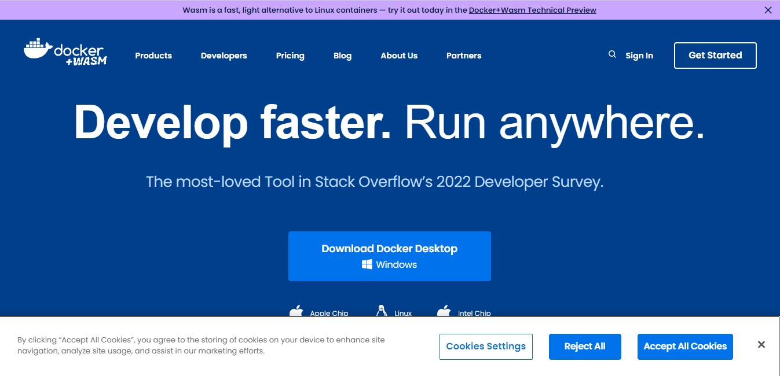

**Step 2.** Goto hub.docker.com register and create an account and login with the same

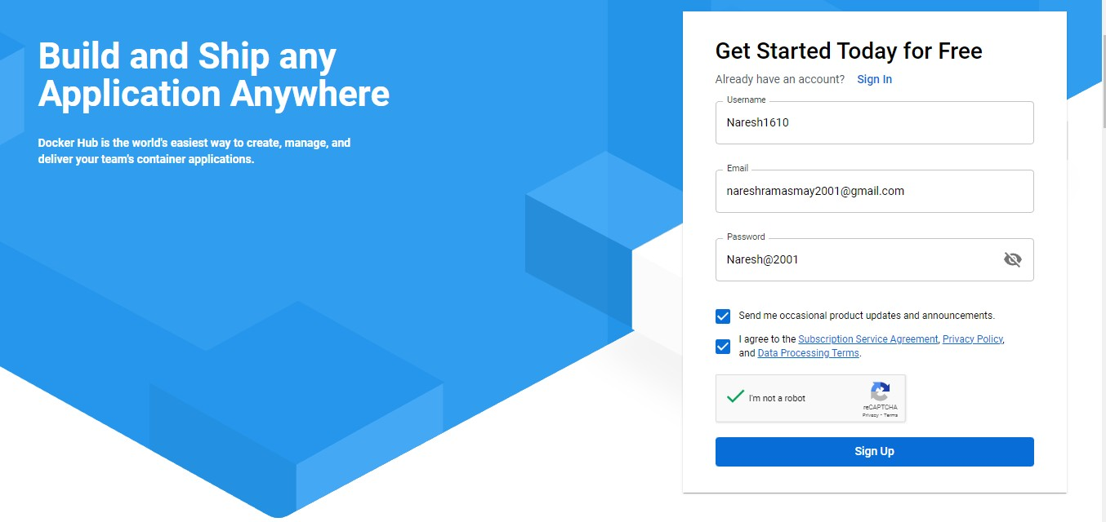

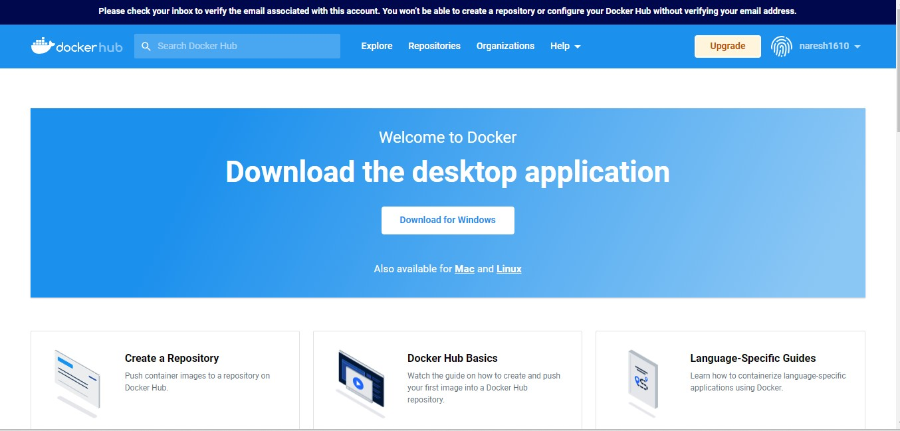

**Step 3.** Open Docker Desktop and start creating containers and images

